PRACTICAL 1
NAME: TASNEEM SADIKOT
PRN: 23070521162
SEM: 5 SEC: B

<html>
<head>
<script>
document.write("Hello World!")
</script>

<noscript>
Sorry...JavaScript is needed to go ahead.
</noscript>
</head>
<body>
</body>
</html>
OUTPUT:
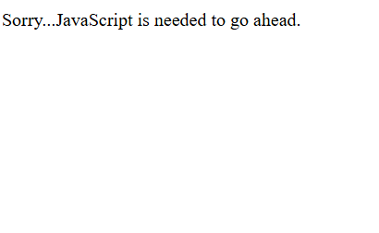
<html>
<body>
<script>
let a = "abc";
let b = "abc";
let c = "ABC";
document.write("a == b? " + (a == b) + "<br>");
document.write("a == c? " + (a == c) + "<br>");
document.write("b == c? " + (b == c) + "<br>");
</script>
</body>
</html>
OUTPUT:
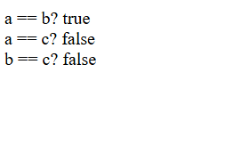
<html>
<body>
<script>
function getSum(first, second) {
var sum = first * second;
document.write("The product of " + first + " and " + second + " is " + sum);
}
let first = 5;
const second = 4;
getSum(first, second);
</script>
</body>
</html>
OUTPUT:
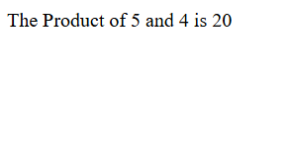
<html>
<body>
<script>
function getSum(first, second) {
var sum = first + second;
document.write("The Addition of " + first + " and " + second + " is " + sum);
}
let first = 5;
const second = 4;
getSum(first, second);
</script>
</body>
</html>
OUTPUT:
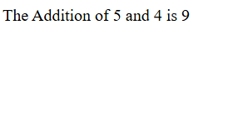
<html>
<body>
<script>
function getSum(first, second) {
var sum = first - second;
document.write("The Subtraction of " + first + " and " + second + " is " + sum);
}
let first = 5;
const second = 4;
getSum(first, second);
</script>
</body>
</html>
OUTPUT:
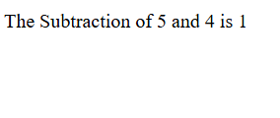
<html>
<body>
<script>
function getSum(first, second) {
var sum = first / second;
document.write("The Division of " + first + " and " + second + " is " + sum);
}
let first = 16;
const second = 4;
getSum(first, second);
</script>
</body>
</html>
OUTPUT:
